Big Mountain Resort is looking to validate their pricing structure currently, to review how much of a rate increase can be sustained along with a review of what features can be diminished to reduce operational costs. The Big Mountain Resort data was gathered then compared with other resorts in Montana along with the entire country.

The data was gathered from across the country then cleaned. We reviewed where there were missing values and if we needed to impute a value or remove the line item. The data was validated so we had unique resort names within each state to avoid duplicate data. Data was reviewed by state then compared across. The price is what really interests us at this time so we reviewed that across each state. Next we targeted features that could impact that price.

After cleaning up the data to review the price and features across the country we are able to dive into which features truly can be used when considering the price of a ticket. We combined state data with the resort data so we could review the data based on state population density along with how many resorts there are to supply the population. With this it helps us know roughly what our market density is. Then we were able to create a heatmap to see where some of the valued features are and their correlation.

Next came the preprocessing and training. Here dummy regressor was utilized with the training functions to predict results effectively. It was training for the mean absolute error of the data along with the mean squared error. These metrics allow us to then scale the data for better comparison. These are then fit in to a pipeline which allowed us to create a random forest regressor. Here we can clearly see certain features impacts.

We did modeling on many different features for Big Mountain Resort and where they fell within their market share. From there pricing was investigated in relation to the market share and changes that have been requested. We show that if we close down up to 5 runs it will have a minor impact in the pricing of the tickets. This will also reduce operating costs. On top of that if a new run is created with additional vertical drop and a new chair lift we can increase the ticket price some.

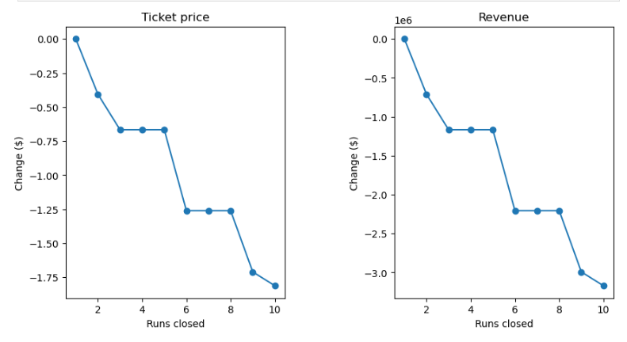

So in conclusion the price should be increased to $82 for an adult ticket. We show that there is room for growth and room to reduce operating costs. In the future we should review on a semi-regular basis to maintain in line with the market share. If we expand on key features we will also be able to increase our rates accordingly.